CE2107 Lab4 Assignment Sheet (to be submitted to NTULearn before next lab)

Name: Ang Kai Jun Lab Group: SEP4 Date: 13/10/20

1. Section 6.1. What is the issue when an obstacle is place to close to the IR sensor? What can you do to prevent such ambiguity?

At distances lower than the maximum turning point of the graph, the corresponding distance can be either on the left side of the turning point or on the right side of the turning point.

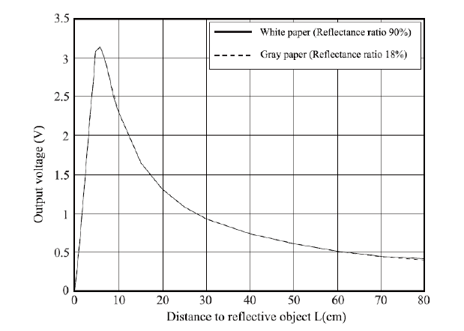

From the figure above, at voltage 2V, distance can either be 33mm or 133mm.

Ambiguity can removed by simply ignoring the distance from 0 to 50mm or the distance corresponding to the maximum turning point of the graph.

1. Section 6.1. What is the purpose of the 10uF decoupling capacitor?  
   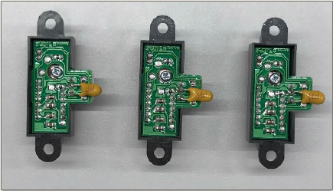

The decoupling capacitor’s purpose is to remove noise from the sensor.

1. Section 6.2. Which port pins is ADC Ch12, 16 and 17 input mapped to? What is the PSELx settings required to configure the pins to ADC function?

ADC Ch 17 is mapped to P9.0 (Right Sensor)

ADC Ch 12 is mapped to P4.1 (Center Sensor)

ADC Ch 16 is mapped to P9.1 (Left Sensor)

PSELx to be set to 1.

1. Section 6.3. With respect to the ADC on MSP432, what are the two stages involved in every Analog to Digital Conversion of a Analog signal?

MSP432 uses 14-bit SAR analog to digital converter. There are 2 stages in the process of converting an analog signal to a digital signal: Sample and Hold stage and actual SAR ADC conversion

Sample and Hold stage is to sample the input voltage, which is then passed to the SAR ADC for digitization in the next stage.

1. Section 6.4. What does the function LPF_Calc() does? What are the initial values of the buffer associated with LPF_Calc()? Why do we need this function?

LPF_Calc() implements a running average algorithm to compute the 14 bit ADC value after digitalized. Whenever a new data is read by sensor, it is added into the sum and then the oldest value will be removed from this sum. Then an average value is computed for the ADC reading of the sensor. This basically create a window of size = s where s is specified in main() of Lab4_ADCmain.c. This window of fixed size will scan through the raw readings of the sensor and output a filtered, average reading of the sensor.

Initial values of the buffers associated to LPF_Calc is a single 14-bit value obtained by reading the sensors once after a warmup “BUSY” period as described in ADC_In17_12_16 function.

It is important to have some sort of filter for the sensor (such as running average in this case) to prevent inaccuracy from sudden overshooting noise (high frequency) from reading noisy sensors. This allows a more accurate value to be obtained for sensor’s ADC values, aiding us in the final linearization to estimate distance process. This is a software filter and serve sort of similar function to the hardware filter (by RC in qns 2, different in what frequency we are filtering).

1. Section 6.4. Describe the algorithm you used to estimate the actual distance based on the IR Sensor value.

Plotted the values of the cleaned data according to length measurements using the formula X=A/(n+B) where X is the length and n is the cleaned data value. Curve was plotted to obtain values of A and B for each of the readings.

Measurements were taken using actual distances. Objects were placed at specific distances from the IR sensors, and they corresponding readings were taken. Various readings were taken, spanning from 10 cm up to 50 cm. The readings were then placed into a software to generate the curve and the formula as stated above.

1. Section 7.2. Which timer capture input (Timer and Channel number) does P8.2 and P10.4 correspond to?

Both correspond to Timer A3 input.

P8.2 corresponds to capture channel 2 of Timer A3 (TA3CCI2A)

P10.4. corresponds to capture channel 0 of Timer A3 (TA3CCI0A)

1. Section 7.2. Which edge (falling, rising, both) is the timer input capture configured to trigger on? What happens when a capture event occurs?

Rising Edge.

On rising edge, timer value is saved by the corresponding CCR register channels. This process is carried out in timer interrupt handlers TA3_0_IRQHandler and TA3_N_IRQHandler which are called when interrupts from Timer A3, channel CCI0A and CCI2A occurs

In the ISR, PeriodMeasure0 and PeriodMeasure2 are executed. They will calculate the period between two rising edges of the tachometers. Using the period, we can calculate the speed of motors.

1. Section 7.2. Why is the calculated value of pulse duration, derived from the timer capture values, not a constant value but seemed to keep changing?

Tachometer has a light emitter and a light collector. The collector receives light from the emitter due to light passing through the holes in the wheels when it is rotating. This generates a voltage value based on amount of light it receives. The reading is then converted from analogue to digital signal which would be either a 1 or 0. There may be fluctuations in the readings due to the continuous nature of the light being received. The pulse would then not occur at constant intervals, hence pulse duration being read would not remain constant.